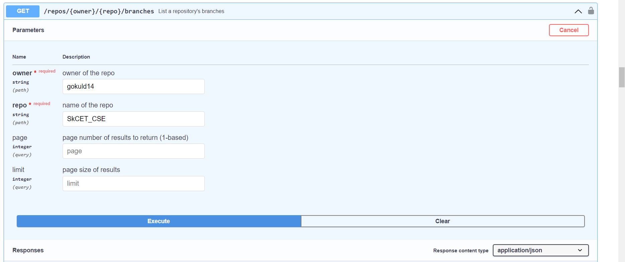

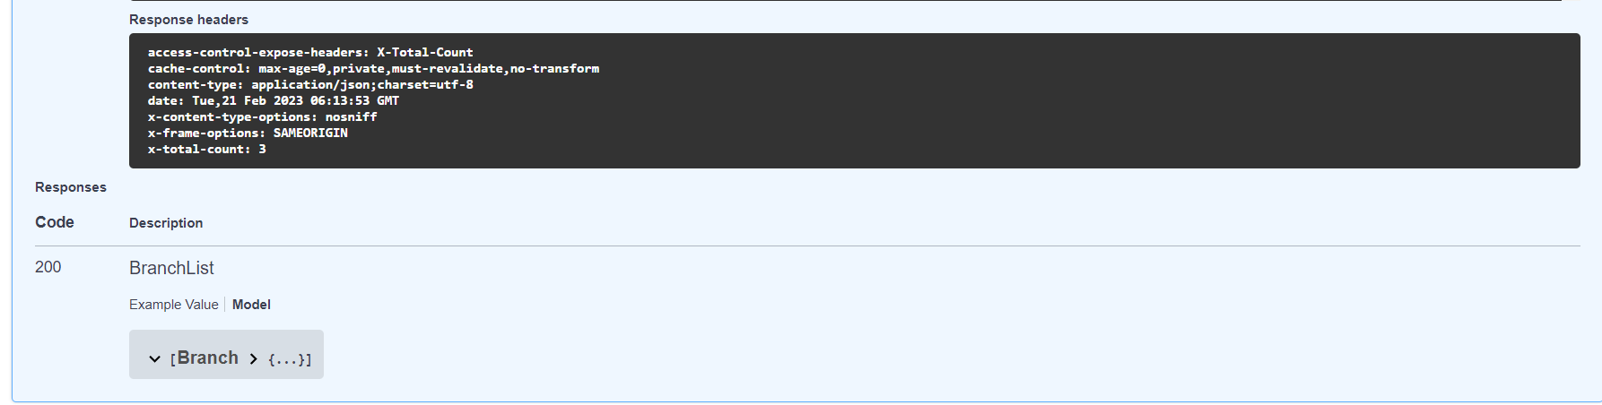

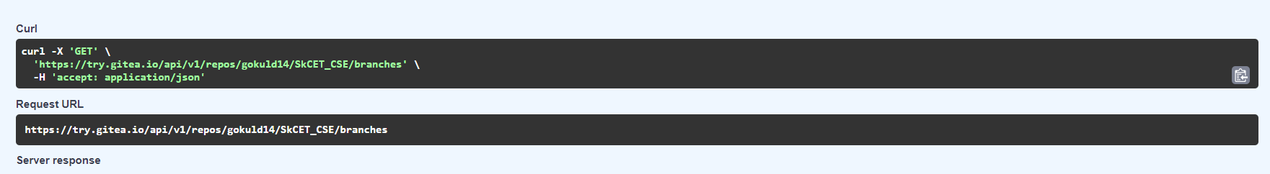

**[**

**{**

**"name": "2nd_branch",**

**"commit": {**

**"id": "7e756226e40af037945edfba243c182bf152baf6",**

**"message": "Initial commit\n",**

**"url": "https://try.gitea.io/gokuld14/SkCET_CSE/commit/7e756226e40af037945edfba243c182bf152baf6",**

**"author": {**

**"name": "gokuld14",**

**"email": "gokuld14@noreply.try.gitea.io",**

**"username": "gokuld14"**

**},**

**"committer": {**

**"name": "gokuld14",**

**"email": "gokuld14@noreply.try.gitea.io",**

**"username": "gokuld14"**

**},**

**"verification": {**

**"verified": false,**

**"reason": "gpg.error.not_signed_commit",**

**"signature": "",**

**"signer": null,**

**"payload": ""**

**},**

**"timestamp": "2023-02-21T06:10:32Z",**

**"added": null,**

**"removed": null,**

**"modified": null**

**},**

**"protected": false,**

**"required_approvals": 0,**

**"enable_status_check": false,**

**"status_check_contexts": [],**

**"user_can_push": false,**

**"user_can_merge": false,**

**"effective_branch_protection_name": ""**

**},**

**{**

**"name": "First_Branch",**

**"commit": {**

**"id": "7e756226e40af037945edfba243c182bf152baf6",**

**"message": "Initial commit\n",**

**"url": "https://try.gitea.io/gokuld14/SkCET_CSE/commit/7e756226e40af037945edfba243c182bf152baf6",**

**"author": {**

**"name": "gokuld14",**

**"email": "gokuld14@noreply.try.gitea.io",**

**"username": "gokuld14"**

**},**

**"committer": {**

**"name": "gokuld14",**

**"email": "gokuld14@noreply.try.gitea.io",**

**"username": "gokuld14"**

**},**

**"verification": {**

**"verified": false,**

**"reason": "gpg.error.not_signed_commit",**

**"signature": "",**

**"signer": null,**

**"payload": ""**

**},**

**"timestamp": "2023-02-21T06:10:32Z",**

**"added": null,**

**"removed": null,**

**"modified": null**

**},**

**"protected": false,**

**"required_approvals": 0,**

**"enable_status_check": false,**

**"status_check_contexts": [],**

**"user_can_push": false,**

**"user_can_merge": false,**

**"effective_branch_protection_name": ""**

**},**

**{**

**"name": "main",**

**"commit": {**

**"id": "7e756226e40af037945edfba243c182bf152baf6",**

**"message": "Initial commit\n",**

**"url": "https://try.gitea.io/gokuld14/SkCET_CSE/commit/7e756226e40af037945edfba243c182bf152baf6",**

**"author": {**

**"name": "gokuld14",**

**"email": "gokuld14@noreply.try.gitea.io",**

**"username": "gokuld14"**

**},**

**"committer": {**

**"name": "gokuld14",**

**"email": "gokuld14@noreply.try.gitea.io",**

**"username": "gokuld14"**

**},**

**"verification": {**

**"verified": false,**

**"reason": "gpg.error.not_signed_commit",**

**"signature": "",**

**"signer": null,**

**"payload": ""**

**},**

**"timestamp": "2023-02-21T06:10:32Z",**

**"added": null,**

**"removed": null,**

**"modified": null**

**},**

**"protected": false,**

**"required_approvals": 0,**

**"enable_status_check": false,**

**"status_check_contexts": [],**

**"user_can_push": false,**

**"user_can_merge": false,**

**"effective_branch_protection_name": ""**

**}**

**]**

